Year: 2026-2027 Sem V-NEP
Course: ASD&D Lab
Experiment 05
Date of Performance: 22/07/2026 Date of Submission: 22/07/2026
Class:T1
Student Roll No: 2401034 StudentName:Bhavisha kewalramani

Aim:
To automate application deployment using GitHub and Jenkins.

Lab Outcome:
Mapped LO3: Build and manage automated CI/CD pipelines for application development, testing, packaging, and deployment.

Theory
Continuous Integration (CI) and Continuous Deployment (CD) form a fundamental DevOps practice aimed at bridging the gap between development and operational activities.

- Continuous Integration (CI): A software development practice where developers regularly merge code changes into a central repository, followed by automated builds and tests. This helps detect bugs early, improves software quality, and reduces validation overhead.

- Continuous Deployment (CD): The automated process where verified changes in the codebase are automatically packaged, configured, and deployed directly to production or staging runtime environments without manual intervention.

- Jenkins & Declarative Pipelines: Jenkins is an open-source automation server enabling automated build, test, and deployment workflows. A Declarative Pipeline uses a structured Groovy-based domain-specific language (DSL) to define stages, steps, and execution environments as code (Jenkinsfile), making infrastructure version-controlled and reproducible.
Step-by-Step Procedure

Step 1: Jenkins Server Initialization and Access Setup

- Jenkins runs as a background Windows service requiring a compatible Java Development Kit (JDK 21) runtime environment to execute its core processes.
- Access the web console at http://localhost:8080 to complete the setup wizard.
- Create the first administrator user to manage permissions, job configurations, and server tasks.

Step 2: Baseline Pipeline Validation (Inline Scripting)

- Create a new project item named GitHub-Jenkins-Demo using the native Pipeline job type.
- Add an inline Declarative Pipeline script directly to the job configuration to test the server's execution engine prior to external version control integration.
- Use the agent any directive along with three core lifecycle stages: Build, Test, and Deploy (each executing standard echo statements).
- Trigger Build #1; verify via the console logs that Jenkins assigns a local node executor in the workspace directory, processes each stage sequentially, and finishes with SUCCESS.

Step 3: Source Code Management (SCM) & Pipeline-as-Code Implementation

- Establish a central GitHub repository named jenkins-demo-app under the user profile to maintain the application codebase and configuration.
- Add an index.html file as the frontend application artifact with an initial header message.
- Define a version-controlled Jenkinsfile in the repository root directory using Declarative Pipeline syntax.
- Script automated batch instructions (bat) within the Deploy stage to verify the destination directory (C:\Deployments\DemoApp) and copy index.html from the workspace to the target folder.

Step 4: Connecting Jenkins to GitHub and Initial Deployment

- Update the Jenkins project configuration from an inline script to Pipeline script from SCM, specifying Git as the source provider.
- Configure the repository HTTPS URL, set the branch specifier to */main, and target the repository's Jenkinsfile.
- Run Build #2 to trigger Jenkins to clone the remote repository, checkout the latest commit, parse the Jenkinsfile, and execute the deployment batch commands.
- Verify deployment by opening C:/Deployments/DemoApp/index.html in a web browser.

Step 5: Continuous Integration & Continuous Deployment (CI/CD) Verification

- Modify index.html directly on GitHub by adding custom CSS styling and updating the text to:
Application Updated & Deployed via CI/CD Pipeline! Version 2.0 is live.
- Trigger Build #3; Jenkins fetches the updated commit hash, executes all stages, and overwrites the existing index.html in C:\Deployments\DemoApp.
- Refresh the browser page to confirm the updated UI and Version 2.0 text, validating the end-to-end automated delivery pipeline.

Execution: -
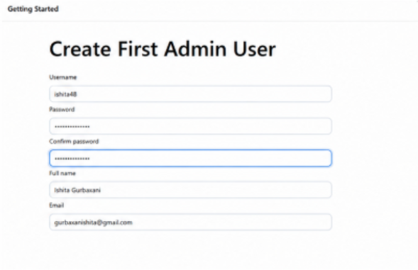
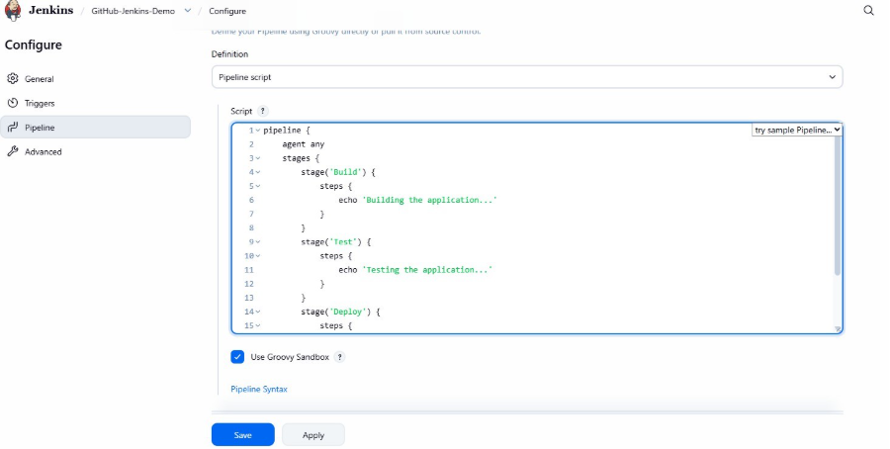
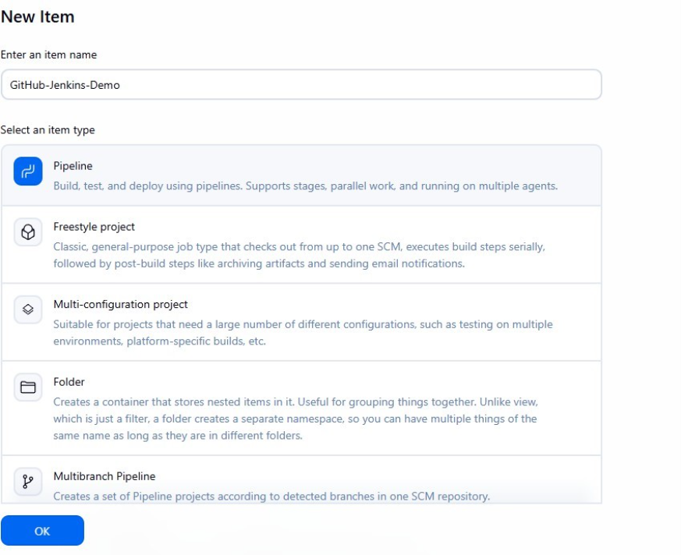
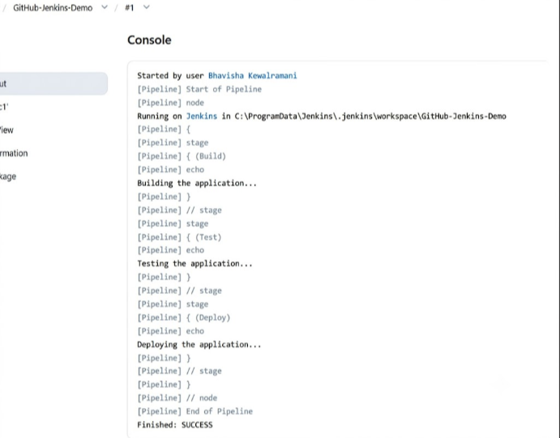
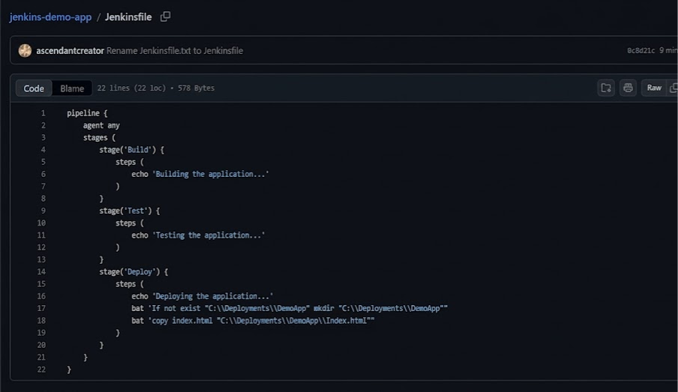
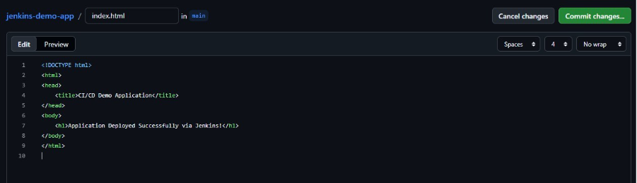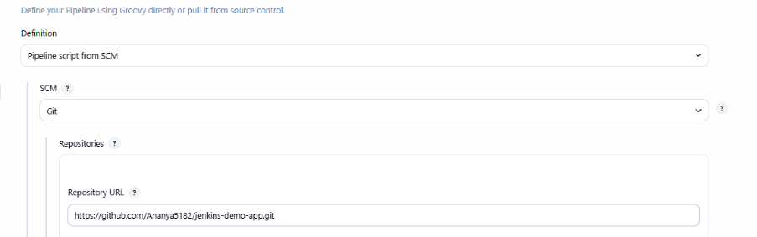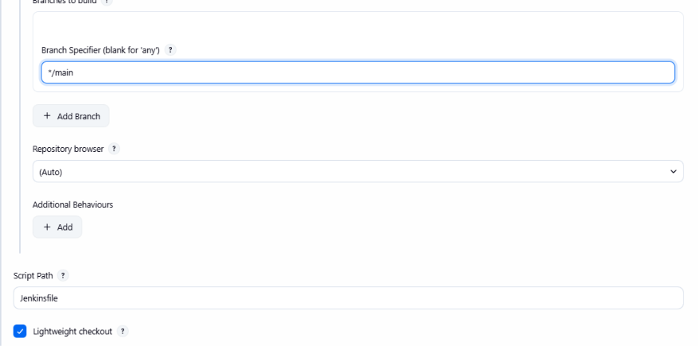
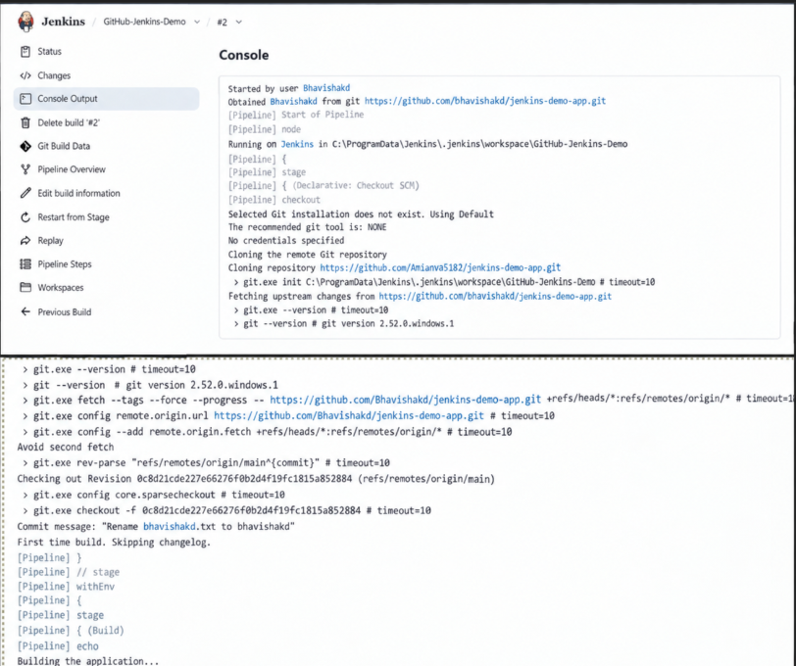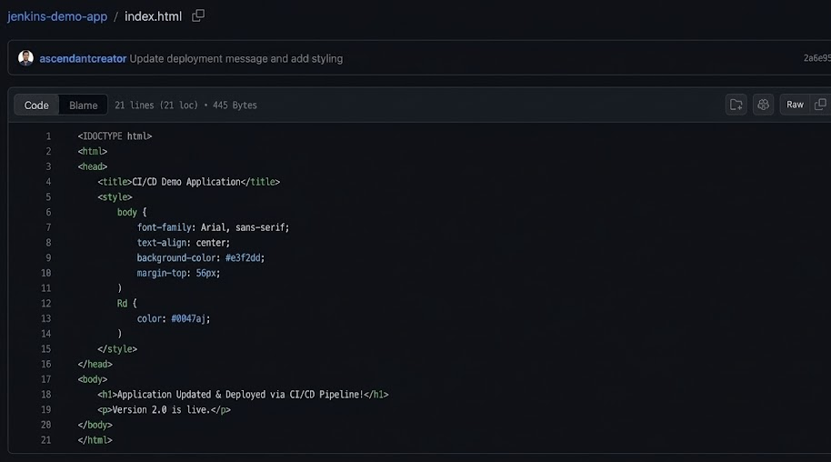
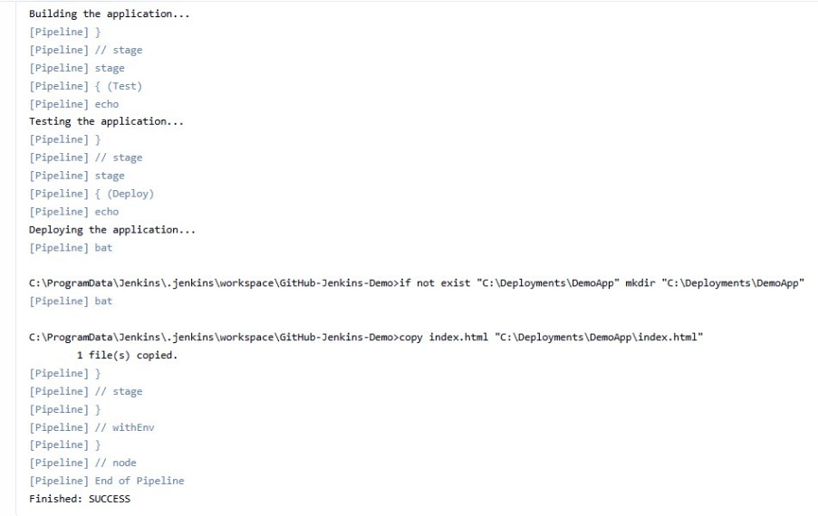
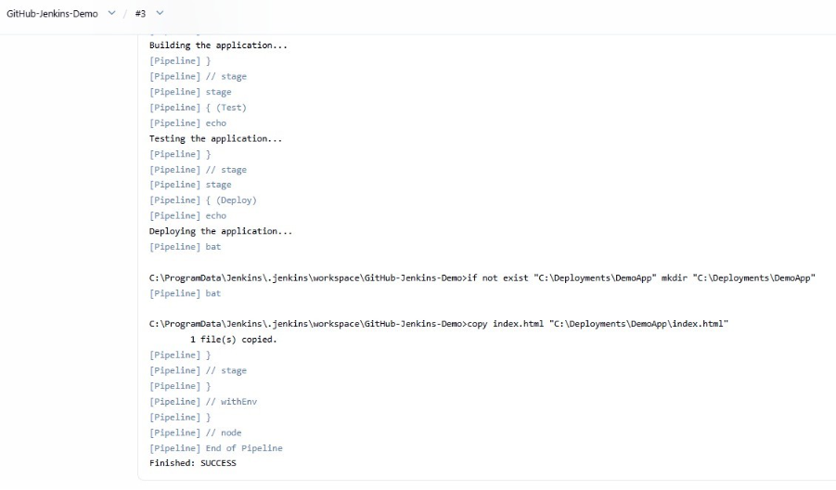
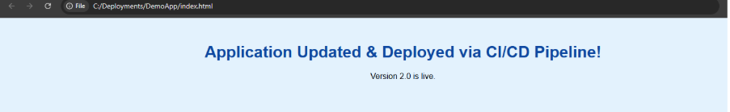Conclusion:
Building and running an automated CI/CD pipeline by integrating Jenkins with GitHub bridges the gap between writing code and shipping it. Through Declarative Pipeline syntax, source code changes are automatically fetched, validated, and deployed to the target environment without manual effort. The primary takeaway is the practical value of Pipeline as Code via a Jenkinsfile, which keeps deployment logic version-controlled, traceable, and reproducible alongside the application. Ultimately, seeing a repository commit instantly reflected in the live setup proves how automated workflows eliminate human error, shorten release cycles, and ensure consistent software delivery.

